Malawi

## Population Data

The data set shows the political stability estimate of the country each year.

## # A tibble: 23 x 5  
## country iso3c date population popCategory5  
## <chr> <chr> <dbl> <dbl> <chr>   
## 1 Malawi MWI 1996 10022789 small   
## 2 Malawi MWI 1997 10264906 small   
## 3 Malawi MWI 1998 10552338 small   
## 4 Malawi MWI 1999 10854322 small   
## 5 Malawi MWI 2000 11148758 small   
## 6 Malawi MWI 2001 11432000 small   
## 7 Malawi MWI 2002 11713664 small   
## 8 Malawi MWI 2003 12000181 small   
## 9 Malawi MWI 2004 12301838 small   
## 10 Malawi MWI 2005 12625952 small   
## 11 Malawi MWI 2006 12973699 small   
## 12 Malawi MWI 2007 13341806 small   
## 13 Malawi MWI 2008 13727890 small   
## 14 Malawi MWI 2009 14128155 small   
## 15 Malawi MWI 2010 14539612 small   
## 16 Malawi MWI 2011 14962112 small   
## 17 Malawi MWI 2012 15396005 small   
## 18 Malawi MWI 2013 15839269 small   
## 19 Malawi MWI 2014 16289540 small   
## 20 Malawi MWI 2015 16745303 small   
## 21 Malawi MWI 2016 17205289 small   
## 22 Malawi MWI 2017 17670260 small   
## 23 Malawi MWI 2018 18143315 small

# Population growth data

## # A tibble: 23 x 5  
## country iso3c date popGrowth popGrowthCat5   
## <chr> <chr> <dbl> <dbl> <chr>   
## 1 Malawi MWI 1996 1.80 moderate growth rate  
## 2 Malawi MWI 1997 2.39 moderate growth rate  
## 3 Malawi MWI 1998 2.76 high growth rate   
## 4 Malawi MWI 1999 2.82 high growth rate   
## 5 Malawi MWI 2000 2.68 high growth rate   
## 6 Malawi MWI 2001 2.51 high growth rate   
## 7 Malawi MWI 2002 2.43 moderate growth rate  
## 8 Malawi MWI 2003 2.42 moderate growth rate  
## 9 Malawi MWI 2004 2.48 moderate growth rate  
## 10 Malawi MWI 2005 2.60 high growth rate   
## 11 Malawi MWI 2006 2.72 high growth rate   
## 12 Malawi MWI 2007 2.80 high growth rate   
## 13 Malawi MWI 2008 2.85 high growth rate   
## 14 Malawi MWI 2009 2.87 high growth rate   
## 15 Malawi MWI 2010 2.87 high growth rate   
## 16 Malawi MWI 2011 2.86 high growth rate   
## 17 Malawi MWI 2012 2.86 high growth rate   
## 18 Malawi MWI 2013 2.84 high growth rate   
## 19 Malawi MWI 2014 2.80 high growth rate   
## 20 Malawi MWI 2015 2.76 high growth rate   
## 21 Malawi MWI 2016 2.71 high growth rate   
## 22 Malawi MWI 2017 2.67 high growth rate   
## 23 Malawi MWI 2018 2.64 high growth rate

## Population trend

The plot shows the population trend of the country.

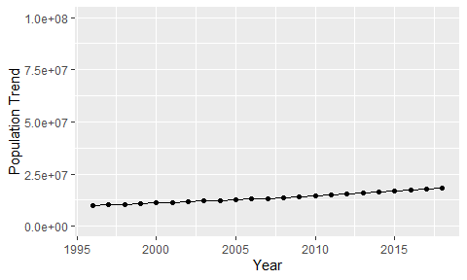

Political Stability Trend

# Population growth trend

The plot shows the population growth rate trend of the country.

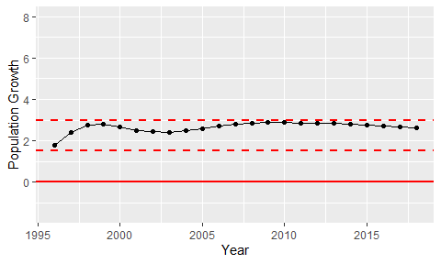

Population Growth Trend